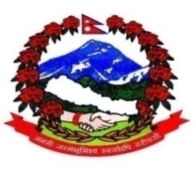
Government of Nepal
Ministry of Agriculture and Livestock Development
Nepal Livestock Sector Innovation Project
Decentralized Level Support Unit, Butwal, Rupandehi
Invitation for Quotation for Dairy Product Diversification Training
Contract Identification No: NP-MOLD-205269-NC-RFQ
Date of 2nd Time publication: February 22, 2021
Name of the Development Partner: The World Bank
Credit Number: [6149 -NP]
- The Nepal Livestock Sector Innovation Project, Decentralized Level Support Unit, Butwal invites sealed quotations from registered CTEVT affiliated institutions for the Dairy Product Diversification/Sweet Maker Training 550 hours (390 hrs class work and 160 hrs OJT) to 12 trainees for total 92 working days.
- Complete set of Bidding Documents may be purchased till March 8, 2021 from the office of Decentralized Level Support Unit (DLSU), Butwal by eligible Bidders.
- Sealed Quotation must be submitted to the office of Decentralized Level Support Unit (DLSU), Butwal by hand on or before 12.00 hrs of March 9, 2021. Quotations received after this deadline will be rejected.
- The quotations will be opened in the presence of Bidders' representatives who choose to attend at 12.30 hrs on March 9, 2021 at the office of Decentralized Level Support Unit (DLSU), Butwal.
Project Coordination Chief
Decentralized level Support Unit, Butwal
Phone: 071-550580, Email: menlsipbutwal@gmail.com

